MS Office HTTPS Connectors

For Microsoft Office, the Microsoft Graph API can be utilized to access data across various Microsoft services including Office, Outlook, OneDrive, SharePoint, and more.

1. [Microsoft Graph API](https://learn.microsoft.com/en-us/graph/use-the-api): This is the primary API for accessing Microsoft services data. It provides RESTful endpoints for interacting with various Office applications and services.
2. [Graph Permissions:](https://learn.microsoft.com/en-us/graph/permissions-overview?tabs=http) Graph permissions for APIs accessing the data are important to implement for a valid response. Permissions can be delegated to the app that is accessing user info.
3. [Graph Endpoints and Graph Explorer](https://developer.microsoft.com/en-us/graph/graph-explorer/): Microsoft Graph provides endpoints for accessing user's documents, emails, calendar events, etc. The Graph Explorer is a playground to test these different APIs and their request/response body.
4. Retrieval of Documents and Reading Text: Using retrieval and read APIs this can be done for both SharePoint and Teams. Users can also use filters or optional parameters to only query between a date range. Some examples are:
   1. List items in my drive: <https://graph.microsoft.com/v1.0/me/drive/root/children>
   2. Get a SharePoint page: [https://graph.microsoft.com/beta/sites/{siteId}/pages/{pageId](https://graph.microsoft.com/beta/sites/%7BsiteId%7D/pages/%7BpageId)}
   3. Get messages in a [teams chat](https://learn.microsoft.com/en-us/graph/api/chatmessage-get?view=graph-rest-1.0&tabs=http): [https://graph.microsoft.com/v1.0/chats/{chat-id}/messages/{message-id](https://graph.microsoft.com/v1.0/chats/%7Bchat-id%7D/messages/%7Bmessage-id)} (Chat.Read.All permissions required)
5. Throttling Limits of the Graph API:
   1. <https://learn.microsoft.com/en-us/graph/throttling-limits>
   2. <https://learn.microsoft.com/en-us/graph/throttling>
   3. <https://learn.microsoft.com/en-us/graph/connecting-external-content-api-limits>

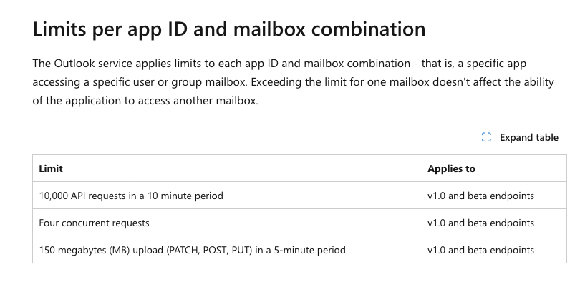

To retrieve all documents for a user:

* An example using the Microsoft Graph API to retrieve documents from the signed in user's OneDrive: GET <https://graph.microsoft.com/v1.0/me/drive/root/children>
* refine this request by specifying query parameters, such as filtering by date range: GET [https://graph.microsoft.com/v1.0/me/drive/root/children?$filter=lastModifiedDateTime ge 2024-01-01T00:00:00Z](https://graph.microsoft.com/v1.0/me/drive/root/children?$filter=lastModifiedDateTime)
* To retrieve documents for another user using the Microsoft Graph API, necessary permissions to access that user's data is required. Typically, this involves obtaining delegated permissions from the user or using application permissions.
* An example of this: GET [https://graph.microsoft.com/v1.0/users/{user-id or user-principal-name}/drive/root/children](https://graph.microsoft.com/v1.0/users/%7Buser-id)

To read the text contents of each document:

* An example of how to download the content of a Word document and extract the text using Microsoft Graph API: GET [https://graph.microsoft.com/v1.0/me/drive/items/{item-id}/content](https://graph.microsoft.com/v1.0/me/drive/items/%7Bitem-id%7D/content)
* Replace {item-id} with the ID of the document you want to retrieve. This will download the content of the document. the response will contain the binary content of the document itself, not the text contents in a readable format.
* To extract the text content from the document, further processing the downloaded binary content using appropriate libraries or tools that can parse the document format and extract the text is required.

Costs of the Graph API:

* Microsoft Graph includes APIs that are available at no additional cost with [user subscription licenses](https://learn.microsoft.com/en-us/microsoft-365/enterprise/subscriptions-licenses-accounts-and-tenants-for-microsoft-cloud-offerings) and APIs and services that are metered. Metered APIs and services in Microsoft Graph incur costs based on usage.
* Microsoft Graph APIs fall into three categories, and metering may apply based on the category of the API.
  + Standard APIs: Most Microsoft Graph APIs are standard APIs. These APIs perform standard operations (create, read, update, delete) on customer content and administrative endpoints. Reasonable access limits for these APIs are defined based on documented [usage thresholds](https://learn.microsoft.com/en-us/graph/throttling-limits)
  + High-capacity APIs: High-capacity APIs ensure that customers and developers have access to data at scale. This category includes purpose-built, bulk export or import endpoints and Microsoft Graph services. These APIs may be metered and incur additional costs beyond user subscription license
  + Advanced APIs: Advanced APIs provide access to enriched or aggregated data, or advanced functionality that extends from Microsoft 365. The [assignSensitivityLabel](https://learn.microsoft.com/en-us/graph/api/driveitem-assignsensitivitylabel) API is an example of an advanced API. These APIs may be metered and incur additional costs beyond user subscription licenses.

To extract calendar events between two dates:

using the Microsoft Graph API, you can extract calendar events for a user between two specified dates. Microsoft Graph API provides access to resources within the Microsoft 365 suite, including Outlook calendar events. The [calendarView](https://learn.microsoft.com/en-us/graph/api/user-list-calendarview?view=graph-rest-1.0&tabs=http) endpoint can be used to get the occurrences, exceptions, and single instances of events in a calendar view defined by a time range, from the user's default calendar, or from some other calendar of the user.

Example Usage:

GET https://graph.microsoft.com/v1.0/me/calendarview?startDateTime=2023-01-01T00:00:00Z&endDateTime=2023-01-31T23:59:59Z